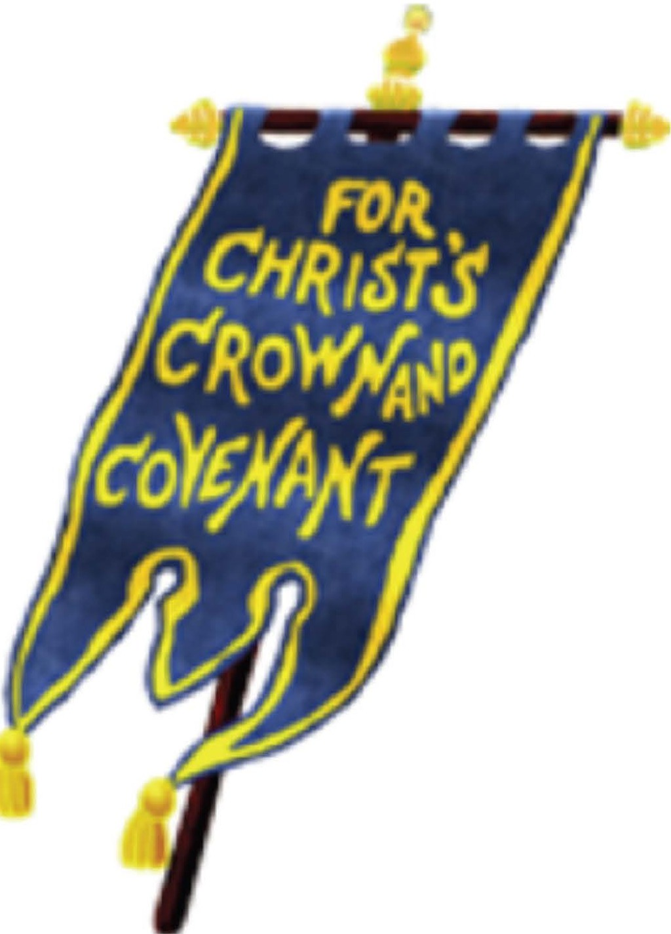

CHILD PROTECTION POLICY GREAT LAKES - GULF PRESBYTERY (RPCNA)

The Great Lakes-Gulf Presbytery takes the protection of her covenant children very seriously. The Covenant of Baptism, noting that children are a possession of God entrusted to the care of his or her parents, requires watchful protection of covenant children by the entire church.

Jesus said, "Let the little children come to me and do not hinder them, for to such belongs the kingdom of heaven. "
"-J Matthew 19:14 "-J

GLG Child Protection Policy 1

CHILD PROTECTION POLICY GREAT LAKES - GULF PRESBITERY (RPCNA)

TABLE OF CONTENTS
- Introduction and Theological Foundation 2
  - Purpose 2
  - Biblical Mandate 2
  - Confessional Foundation 2
- Scope and Definitions 2
  - The Scope of This Policy 2
  - Definitions of Key Terms 3
- Policies and Procedures 3
  - Selection of Workers 3
  - Maintenance of Records 4
  - Supervision and Visibility 4
  - Restroom Guidelines 5
  - Check-in and Check-out S
  - Discipline S
  - Transportation of Children S
  - Overnight Trips 6
  - Sick Children 6
  - Medications 6
  - Accidental Injury 6
  - Training 7
  - Communicating the Presbytery Child Protection Policy 7
- Reporting Suspected Abuse 7
- Appendix A: State Requirements for Reporting Abuse 9
- Appendix B: Forms 10
  - Youth Ministry Staff Application Form 10
  - Medical Release Form 13

GLG Child Protection Policy 2

INTRODUCTION AND THEOLOGICAL FOUNDATION

Purpose
These procedures and policies have been developed to ensure a safe, loving environment conducive to the protection and care of children during youth ministry programs of the Great Lakes-Gulf Presbytery (GLGP) of the RPCNA.

Biblical Mandate
Matthew 19:14 - Jesus said, "Let the little children come to me and do not hinder them, for to such belongs the kingdom of heaven."
John 21:15- So when they had eaten breakfast, Jesus said to Simon Peter, "Simon, son of Jonah, do you love Me more than these?" He said to Him, "Yes, Lord; You know that I love You." He said to him, "Feed My lambs."

Ephesians 5:3 - But among you there must not be even a hint of sexual immorality, or of any kind of impurity, or of greed, because these are improper for God's holy people.

Confessional Foundation
Confession of Faith L6 - ... There are some circumstances concerning the worship of God, and government of the Church, common to human actions and societies, which are to be ordered by the light of nature and Christian prudence, according to the general rules of the Word, which are always to be observed.
Testimony XXIV.30 - Education of children is primarily the responsibility of parents, though they may delegate part of this responsibility to the church or other agencies ...
Directory for Church Government L8- Members should willingly consecrate their talents and gifts to the service of Christ. They should prayerfully consider accepting a position in the church when called to do so.

SCOPE AND DEFINITIONS

The Scope of This Policy

This Policy applies to GLGP programs for youth under the age of 18. This Policy provides basic guidelines that are to be read and interpreted in light of the Constitution of the Reformed Presbyterian Church of North America. Those responsible for presbytery youth programs may create additional or stricter procedures.

GLG Child Protection Policy 3

The policy applies as well to vulnerable adults.

Definitions of Key Terms
    - Child Abuse - Child neglect, child physical abuse, or child sexual abuse.
      - Child Neglect-Depriving a minor of his or her essential needs, such as adequate food, water, shelter, safety, and medical care.
      - Child Physical Abuse - Any use of violence or threats of violence toward a minor, apart from the proper and biblical sphere of a parent's loving and corrective discipline of their child.
      - Child Sexual Abuse - Any contact or interaction (visual, verbal, or emotional) between a minor and another person in which the minor is being used for the sexual arousal, molestation, or gratification of the perpetrator or any other person.
- Event Staff (“Staff”) – Anyone eighteen (18) years of age or older who is approved by the CYPU Director and/or CYPU Board to administer a GLGP Youth program, examples include but are not limited to event coordinator, counselor, driver, cook.
- Presbytery Youth Leadership ("Leadership") - Any GLGP-sanctioned leadership of an official GLGP youth program (e.g., Covfamikoi Director, Youth Secretary, Youth Committee).
- Volunteer. Any adult (18 years or older) or youth, ages 13-17 year of age, approved under this policy to assist in the care of youth at a GLGP youth program.
- Vulnerable Adult-Any person 18 years of age or older who is unable to legally consent, unable to comprehend, or is otherwise particularly susceptible to coercion or abuse (e.g., those who are mentally or physically disabled).

- Youth (a.k.a., children, minors). Those the age of 18 years of age or younger.

7) Background Check: Background checks will be administered by the GLGP Ministry Safe account every three years.
- Application Forms: used for review of event staff will be required one-time only.
- Member in good standing: Member of a congregation of the RPCNA as determined by the local session of the applicant.

GLG Child Protection Policy 4

POLICIES AND PROCEDURES
  - Selection of Workers
Only approved and Staff and Volunteers may serve in the various youth ministries of the Great Lakes-Gulf Presbytery.
    - In order to be eligible to serve as Staff, a person must:
      - Be aged eighteen (18) years of older;
      - Be a communicant member in good standing of a congregation of the RPCNA for the past six months.
      - Submit the Youth Ministry Application and Disclosure Form (see Appendix B) to event leadership

      - Complete a criminal background check through the Great Lakes Gulf Presbytery's MinistrySafe account;

      - Satisfy the training requirements of event leadership.

    - In order to be eligible to serve as a Volunteer, a person must:
      - be at least 13 years old;

      - be a member in good standing of an RPCNA congregation; and

      - must remain under Staff supervision (i.e. persistent monitoring and instruction during an event).

Maintenance of Records
Staff and Volunteer applications, disclosure statements, and up-to-date background checks are to be stored in the Presbytery's MinistrySafe Account.

GLG Child Protection Policy 5

Supervision and Visibility

    - Wherever possible, a ratio of 1 Staff or Volunteer to every 12 students should be maintained during any presbytery youth programming. For children five and younger, Leadership should make every reasonable effort to achieve a ratio of approximately 1 adult for every 8 children.

    - Regardless of group size, Leadership must assign at least one Staff who must be present with any group of youth at all times.

    - Where there are only two Staff or Volunteers in a group, they must be from different households.
    - Some youth classes or small groups may have only one Staff in attendance during the class session. In this case, there should be no fewer than three students with the Staff. In addition, designated personnel should be on call to provide supervision and assistance as needed.

    - Clear visibility should be maintained at all times, and doors left unlocked while rooms are in use.
    - Personnel should avoid being alone with a child in a room.

    - Two or more personnel designated by Leadership may speak with a single child when appropriate (e.g., for counseling or discipline) as long as clear visibility is maintained and any doors left open or unlocked.

    - Staff and Volunteers should engage in active supervision while youth are under their care.

Restroom Guidelines

  - Children five years of age and younger should use a classroom bathroom if one is available. If a classroom bathroom is not available, personnel should escort children in a group, never taking a child to the bathroom alone. Personnel should check the bathroom first to make sure that it is empty, and then allow the children inside. Personnel should then remain outside the bathroom door and escort the children back to the classroom.
  - If a child is taking longer than seems necessary or calls for help, Staff should assist, but leave doors open.

3) For youth over the age of five and under 13, when possible, at least one male Staff or
Volunteer should take two or more boys to the restroom and at least one female
Staff or Volunteer should take two or more girls. The worker should then remain
outside the bathroom door and escort the youth back to the classroom when the youth are done.

GLG Child Protection Policy 6

Check-in and Check-out

Presbytery Youth Leadership will create a process for children fifth grade and younger to be signed in and out only by a child's parents/guardians, or individuals approved by them who are at least 13 years of age or older.

Discipline

  - Correction should be calm, respectful, and discrete; it should not be harsh or belittling.
  - Staff will not administer physical discipline and will only restrain a child if judged necessary to prevent physical injury.

  - Parents should be contacted for any serious or persistent discipline issues.

  - Staff may restrict participation in particular activities. Decisions about suspension or expulsion from a program will be made by Leadership.

Transportation of Children

  - It is the responsibility of parents, not Staff or Leadership, to secure transportation to and from events.

  - During an event, if transportation is required, before a Youth may ride in a staff member's personal vehicle, the driver must be approved by Leadership and the parents must give consent. Staff must also possess adequate liability insurance.

  - When youth are transported during events for presbytery youth activities, they shall be transported in groups or three or more youth, with at least one Approved Adult in each vehicle.

Overnight Trips

Boys and girls should be lodged separately, with at least two male Staff for the boys and two female Staff for the girls.

Sick Children

It is our desire to provide a healthy and safe environment for all involved in presbytery youth programs. To that end, parents will be encouraged to be considerate and not to have their children participate if they have common symptoms of a contagious illness (e.g., fever, vomiting, diarrhea).

Youth who are observed by Staff to be ill will be separated to the extent possible and their parent or guardian will be asked to pick the child up.

GLG Child Protection Policy 7

Medications

  - Except in a medical emergency, Staff will not administer either prescription or non-prescription medications to the children under their care absent a plan that includes prior written consent. Nor may children administer any medications to themselves or others absent a plan that includes prior written consent. In no case may one child share a medication with another child.

  - Families participating in a youth program will be required to complete a Medical Release Form. Leadership or Staff will work with families to have a medical action plan on file for youth with a known condition that may require treatment during an event (e.g., need for an inhaler or epi-pen).

Accidental Injury

In the event that a child is injured while under our care, the following steps should be followed:
- For minor injuries, scrapes, and bruises, Volunteers will provide basic first aid (Band-Aids, etc.) as appropriate and will notify the child's parent or guardian of the injury at the time the child is picked up from our care.

- For injuries requiring medical treatment beyond simple First Aid, the parent(s) and/or guardian will immediately be summoned by Staff in
addition to Leadership (or designee). If Staff or Leadership judge necessary, an ambulance will be called.

- For injuries requiring treatment by a medical profession, Leadership will ensure relevant personnel complete an incident report.

Training

Leadership must review the child protection policy with Staff.

Communicating the Presbytery Child Protection Policy

This Policy is to be made available to anyone attending a GLGP youth program.

GLG Child Protection Policy 8

REPORTING SUSPECTED ABUSE

- Anyone suspecting abuse or neglect must report that suspected abuse or neglect to the relevant authorities as required under applicable law.

- Anyone suspecting that abuse has occurred during a presbytery youth program and involving a participant should immediately notify Leadership so that the matter may be responded to in a timely manner and reasonable precautions be taken.

- Leadership will promptly seek to ascertain the basic facts.

- Unless there is clear and immediate indication that the accusation is without merit, then Leadership will relieve the suspected offender of all responsibilities involving contact with youth, pending further review. Leadership will implement measures to separate the alleged offender from the alleged victim for the duration of the presbytery event, as well as to prevent unsupervised contact by the accused with other youth.

- Once leadership has conducted its initial inquiry and taken initial steps to safeguard potential victims, leadership will promptly notify the parents or guardians of any youth involved, whether an alleged abuser or an alleged victim.

- Leadership will notify the chairman of the Ad Interim Commission (AIC) of the Great Lakes Gulf Presbytery (GLGP), which will ensure that the GLGP's insurance carrier is notified, as well as the moderators of the sessions of the parties to the allegations.

- Any other initial steps taken in response to an allegation of child abuse or neglect will be directed by the AIC (e.g., designating a media spokesperson), consistent with its authority and the Constitution of the RPCNA.

- All steps taken by presbytery leadership will be documented and will be taken without undue delay.

- All communications related to any alleged child abuse or neglect shall attempt to protect the dignity and privacy of those involved, including the alleged child victim and the person suspected of child abuse, while at the same time ensuring that those responsible for addressing the situation, including civil authorities, remain fully informed. The identities of minors will be withheld and protected.

- Presbytery will seek forgiveness and reconciliation in Christ between all parties involved in an investigation or trial, and the restoration of the penitent to communicant membership in the Church, in accord with the Constitution of the RPCNA.

GLG Child Protection Policy 9

APPENDIX A: STATE REQUIREMENTS FOR REPORTING ABUSE
Below are online resources from each state's (under the jurisdiction of the Great Lake Gulf Presbytery) government outlining mandatory reporting requirements and giving points of contact for each state for reporting at the time of this writing; links and information may be updated and should be checked for the most up-to-date information. Furthermore, www.childwelfare.gov provides a centralized library for state laws and handbooks.

Alabama
https://dhr.alabama.gov/child-protective-services/written-report-of-suspected-child-abuse­ neglect-for-mandated-reporters/

Florida
https://www.myflfamilies.com/service-programs/abuse-hotline/
Georgia https://cps.dhs.ga.gov/Main/Default.aspx
Illinois https://www2.illinois.gov/dcfs/safekids/reporting/Pages/index.aspx
Indiana
https://www.in.gov/dcs/contact-us/child-abuse-and-neglect-hotline/
Kentucky

https://chfs.ky.gov/agencies/dcbs/dpp/cpb/Pages/default.aspx

Michigan
https://www.michigan.gov/mdhhs/0,5885,7-339-73971 7119 50648 44443-157836-,00.html
North Carolina
https://www.ncdhhs.gov/divisions/social-services/child-welfare-services/child-protective­ services/about-child-abuse-and-child-neglect
Ohio https://ifs.ohio.gov/ocf/reportchildabuseandneglect.stm
South Carolina
https://dss.sc.gov/child-well-being/report-child-abuse-and-neglect/
Tennessee

https://www.tn.gov/dcs/program-areas/child-safety/reporting/fags.html

GLG Child Protection Policy 10

APPENDIX B: FORMS
YOUTH MINISTRY STAFF APPLICATION FORM GREAT LAKES - GULF PRESBYTERY (RPCNA)

All information on this application will be kept confidential. If you have any questions about the application, please call or email the Presbytery Youth Leadership overseeing the event.

Basic Information
Name:

Phone: _

Date of birth: SSN: _ Email: _ Address:
How many years have you been a communicant member of the RPCNA? _ Are you currently a communicant member of the RPCNA in good standing? _ Current Congregation:

Experience

Describe any relevant experience working with youth.

List any involvement you have had in youth programs in the last 5 years.
Organization Program Dates Contact (email/phone)

GLG Child Protection Policy 11

Character References
Applicants must include a letter of recommendation from a member of their session.

In addition, list two individuals who can attest to your character and, if possible, have observed your interactions with children and youth. References must be 18 or older and may not be members of your household.

Name Relationship Phone Email

History

Have you ever been:
  - Arrested for any reason?
  - Convicted of, or pleaded no contest to, any crime involving minors?
(circle one) Yes / No Yes / No

  - Convicted of, or pleaded no contest to, a moving violation in the last 3 years? Yes / No

Is there any reason why you should not work with minors? Yes / No

*If the answer to any of these questions is "Yes," please explain on a separate sheet of paper.

Affirmations

Place your initials on each line.

I have carefully read the GLGP Child Protection Policy.

I recognize that the GLGP is relying upon the accuracy of the information contained herein. Accordingly, I attest and affirm that all the information that I have provided is completely true and correct, to the best of my knowledge.

I authorize GLGP to contact any person or entity listed in this application and I further authorize any such person or entity to provide GLGP with information, opinions, and impressions relating to my background or qualifications.

I further authorize GLGP to conduct a criminal background investigation and/or child abuse investigation if further investigation is deemed necessary.

GLG Child Protection Policy 12

I voluntarily release GLGP and any such organization or entity listed herein by me from liability involving the communication of information relating to my background or qualifications.

Attachments

Please remember to include the following with this application form:

- A copy of your driver's license.
- (If necessary) Explanation of answers.

Applicant Signature Date

Parent/Guardian Signature (if applicant is under 18) Date

For Administrative Use Only

Date Submitted and Received: Date Background Check Submitted: _ Date Background Check Results Received: _ Application Approved _ Application Denied _ Date of Application Approval or Denial _

GLG Child Protection Policy 13

MEDICAL RELEASE FORM
GREAT LAKES - GULF PRESBYTERY (RPCNA)
THIS INFORMATION WILL BE KEPT CONFIDENTIAL

Great Lakes-Gulf Presbytery Youth Program

Child's Name Date of Birth
M F
Sex

Parent's/Guardian's Name Parent's/Guardian's Name

Parent'sfGuardian's Phone Parent's/Guardian's Phone

Address

Alternative Emergency Contacts

Primary Emergency Contact Secondary Emergency Contact

Primary Contact Phone Number Secondary Contact Phone Number

Primary Contact Street Address Secondary Contact Street Address

Primary Contact City, State, Zip Secondary Contact City, State, Zip

Medical Information

Hospital/Clinic Preference

Physician's Name Physician's Phone Number

Insurance Company Policy Number

Allergies/Special Health Considerations

GLG Child Protection Policy 14

I authorize all medical and surgical treatment, X-ray, laboratory, anesthesia, and other medical and/or hospital procedures as may be performed or prescribed by the attending physician and/or paramedics for my child and waive my right to informed consent of treatment. This waiver applies only in the event that neither parent/guardian can be reached in the case of an emergency.

Parent's/Guardian's Signature Date

I give permission for my child to attend the youth program of the Great Lakes-Gulf Presbytery. I release the Great Lakes-Gulf Presbytery and individuals from liability in case of accident during activities related to the youth program as long as normal safety procedures have been taken.

Parent's/Guardian's Signature Date

For Administrative Use Only

Date Received:

